**Database task**

Create appropriate queries to structure or find the data using the following online DB:

<https://www.w3schools.com/sql/trysql.asp?filename=trysql_select_all>

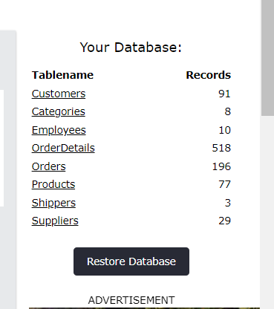

You can provide the results of your work as inserted quires or screenshots from the DB where your queries + DB responses will be seen.

**Tasks:**

1) Select all the information about Categories.

2) Select all the information about the first 7 Customers.

3) Select the following information about Employee: ID, Last Name, Notes.

4) Select only distinct (different) Customers’ ID from Orders table

5) Select the information about the product names and their prices and sort them in **ascending / descending** orders (two separate queries).

6) Select the orders delivered the shippers with ID=3. The result should consist of 3 columns: OrderID, OrderDate and ShipperID.

7) Select information about the Customers whose cities are Lyon and Reims. The result should consist of 3 columns: CustomerID, CustomerName, City.

8) Select all the information about Categories which names start with C.

9) Select the information about Employee whose first names contain the second ‘A’ letter. The result should consist of 3 columns: last name, first name, birthdate.

10) Select the information about the Categories whose names DO NOT start with D